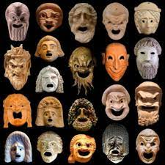
In Year 9 Drama I will study…

The History of Theatre
I will complete a group research project into a particular time in the history of theatre. I will find out about the plays, playwrights, buildings etc. of that time and teach my class what I have found out. I will devise a quiz for my class on my chosen theatrical period and perform an extract with my group from a play written in that time. I will design a suitable costume for the chosen play.

How to write a Playscript
I will learn about the essential elements of a script (layout, plot, dialogue, action) and how professional playwrights go about writing their plays. I will use what I have learnt to write a play of my own. I will direct my classmates in a performance of an extract from my play.
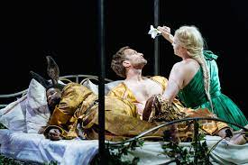
A Midsummer’s Night’s Dream
I find out about the plot, characters and setting of Shakespeare’s play. I will read and watch extracts from the play. I will learn how to use rehearsal methods to perfect my performance of an extract from the play. I will design a stage set and a soundscape for a performance of the play.

I will be assessed throughout the year and at least one assessment (CAT) per topic will involve a performance element.

