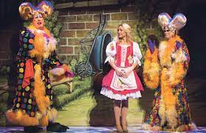
In Year 8 Drama I will study…

The theatrical genre Pantomime.
I will learn about the performance style of the Pantomime stock characters. I will create a group performance of a pantomime. I will write a scene for my own pantomime and design a costume for the Pantomime Dame.
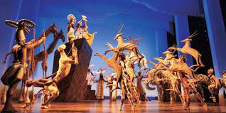

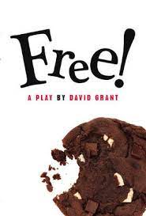
The history of Puppets in theatre.
I will research the different types of puppet theatre produced around the world. I will discover how puppets are made and used in theatre today. I will create my own simple puppet and use that puppet in a recorded puppet show.

How to devise a play.
Using the playscript ‘Free’ my group and I will devise our own play in which a Yr. 8 class are left to their own devices when a cover teacher does not turn up. I will learn how to use different Drama strategies to devise a play and how to use rehearsal methods to improve my performance.

I will be assessed throughout the year and at least one assessment (CAT) per topic will involve a performance element.

