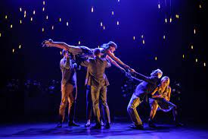
In Year 10 Drama I will study…
Physical Theatre
I will complete research into the physical theatre company, Frantic Assembly. I will learn about the methods they use to devise their physical theatre productions. I will use their methods to produce a short choreographed fight scene with a partner.

Romeo and Juliet
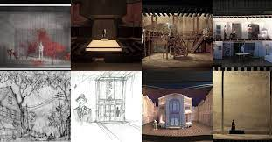
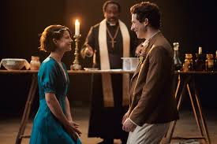
I find out about the plot, characters and setting of Shakespeare’s play. I will read and watch extracts from the play. I will learn how to use rehearsal methods to perfect my performance of an extract from the play. I will find out about Shakespeare’s London and theatre at the time the play was written. I will cast the play and direct others in a performance of extracts from the play.

Technical Theatre
I will find out about the different design roles in the theatre: costume, sound, lighting, set etc. I will create a range of designs for a variety of plays.

I will be assessed throughout the year and at least one assessment (CAT) per topic will involve a performance element.

