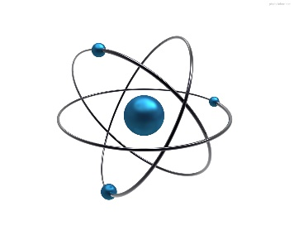**Ballymena Academy Physics**

**Year 9 Revision Checklist**

**Summer 2025**

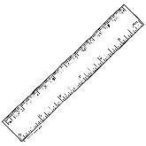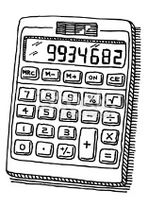Please ensure you bring the following items with you on the day of the exam:

* Pen(s) and pencil(s).
* 30 cm ruler
* Scientific Calculator

**The following is a list of topics which will be examined:**

Please refer to the individual pupil notes booklets for a full list of learning outcomes.

**Light:**

* Luminous and non-luminous sources
* Properties of light
* Pinhole camera
* Shadows
* Reflection
* Properties of an image
* Refraction
* Lenses
* Colour mixing
* Dispersion

**Motion:**

* Speed calculations
* Experiment – how ramp height affects speed
* Distance – Time Graphs.
* Rate of change of speed