Year 9 Biology Revision Checklist and Key points
Remember to check that you know each learning outcome from page 2. All learning outcome could be asked unless specifically mentioned below.
Animal Reproduction | Test your revision...Can you explain each of the key points below? |  |  |  |  |  |  |  |  | Revised?  ✓ 
Learning Outcomes 1-4 | Male and Female sex cells
 | What are each called? |  |  | When are they produced? |  |  |  | Where are they stored?
 | What is internal fertilisation? |  |  |  |  | What is external fertilisation?
Learning Outcomes  5-10 | 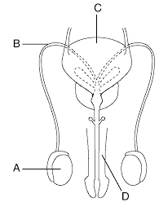 |  |  |  |  | 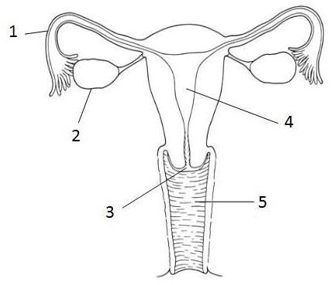
 | Label the Parts:  A:  B:  C:  D: |  |  |  |  | Label the Parts:  1:  2:  3:  4:
 | What are the functions of all the parts A-D |  |  |  |  | What are the functions of all the parts 1-5
 | In which part of the female system does ovulation take place? |  |  |  |  | In which part of the female system does fertilisation take place?
Learning Outcomes 11-15 | What happens during the menstrual cycle? |  |  | What is implantation? |  |  |  | What is puberty?
 | List two changes during puberty in
 | Boys  1.  2. |  |  |  | Girls  1.  2.
 | Mechanical contraception |  |  |  | Chemical contraception
 | Example: |  |  |  | Example:
 | STD protection? |  |  |  | STD protection?

Plant Reproduction | Test your revision...Can you explain each of the key points below? |  |  |  |  |  |  | Revised?  ✓ 
Learning Outcomes 16-20 | 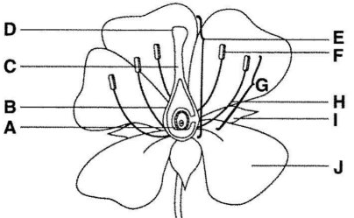
 | A:  B:  C: |  |  |  | D:  F:  I:  J:
 | Is the flower above wind or insect pollenated? | Self-pollination is when… |  |  |  | Cross pollination is when…
Learning Outcomes  21-25 | 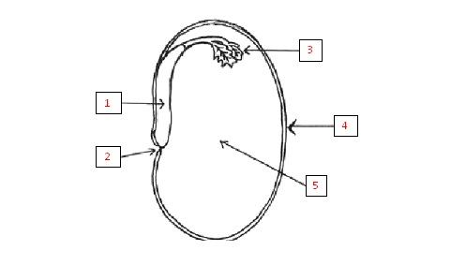 |  | Name parts  1:  2:  3:  4:  5:
 | Four Methods of Seed Distribution  1.  2.  3.  4. |  | What is germination?
Germination requires…
W
O
W
Remember to bring to your exam
- 2 Pens
- Pencil
- Ruler
- Calculator
Scientific Skills
Can you…
- Read scales
- Read tables
- Plot Graphs

