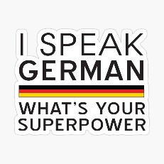
Year 9
The Big Picture
Wilkommen! Welcome!
TOPICS:
- My World and Me
  - Greetings
  - Numbers
  - Where I live
  - Characteristics
  - Favourite things
- Family and Pets
  - Pets
  - Family members
  - Colours
  - Descriptions
  - Birthday
- Freetime
  - Sport
  - Hobbies
  - Freetime Activities
  - Online Activities
- School
  - Subjects, opinions and reasons
  - Timetable
  - Teachers
  - Classroom

In Year 9, you will build on what you learned during your Year 8 fun introduction to German. You will learn lots of useful words and phrases from a variety of topics as covered in the Stimmt! 1 textbook. You will gain the language skills of Listening, Speaking, Reading and Writing.
Homework:
You will have regular learning and written homework. It is very important that you learn new words thoroughly.
Exams and Tests:
Before Christmas and in June you will have an exam which will test the skills of listening, speaking, reading and writing. You will also have regular vocabulary tests.
Some useful websites:
www.pearsonactivelearn.com
https://www.goethe.de/ins/gb/en/spr/unt/kum/dfk/dff/ma1.html
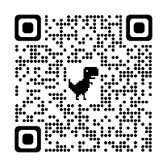
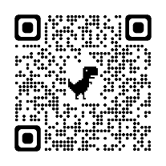
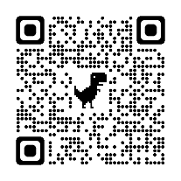
Viel Spaß!

