Year 8 Science Revision Checklist and Key points
Remember to check that you know each learning outcome from pages2-3.
All learning outcomes could be asked unless specifically mentioned below.

Being a Scientist | Test your revision...Can you explain each of the key points below? |  |  |  |  |  |  |  | Revised?  ✓ 
Learning Outcomes 1-5 | List two things you shouldn’t do in the science lab
 | Can you identify each of these hazard symbols… |  | 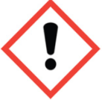 |  |  | 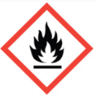
 | 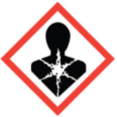 |  | 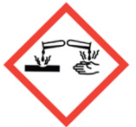 |  |  | 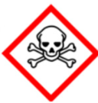
Learning Outcomes 6-8 | 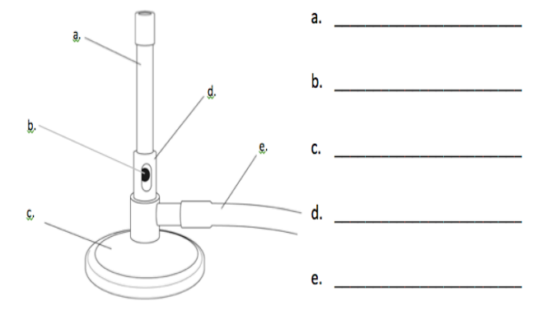  Label the parts of the Bunsen
 | What steps do you take to light the Bunsen? |  | How do you get a yellow flame? |  |  | How do you get a blue flame?
Learning Outcomes 10-14  (Learning outcome 9 not required) | Drawing diagrams?  - Draw in Pencil  - Label in Pen  - Draw in section (no 3D diagrams) |  |  |  | 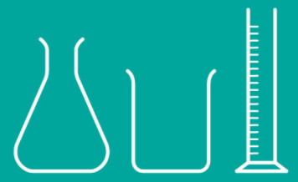
 | Draw a diagram to show the apparatus (assembled) required to heat water in a boiling tube
 | What colour will the flame be when following are placed into the Bunsen? |  | Copper |  |  | Sodium |  | Potassium
Learning Outcomes 15-23 | Write the units and apparatus required to measure |  |  |  |  | Unit |  | Apparatus
 |  |  | Temperature
 |  |  | Time
 |  |  | Length
 |  |  | Volume
 |  |  | Mass
Learning Outcomes 24-30 | Can you follow a branching key? |  |  |  |  | Can you follow a statement key?
Learning Outcomes 31-37  (Learning outcomes 38-40 not required) | Success criteria for drawing a table  - A title describing the contents of the table.  - Headings for each column.  - Units in the headings where necessary.  - Lines drawn neatly using a pencil and ruler.
 | What is an independent variable? |  |  | What is a dependent variable? |  |  | What is a controlled variable?

Remember to bring to your exam
- 2 Pens
- Pencil
- Rubber
- Ruler
- Calculator

