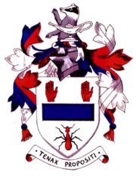
Qu 1

Olaf ate 24 ice cream cones in 2019. In 2020 he says he will eat 25% more ice cream cones.

How many cones will he eat in 2020?
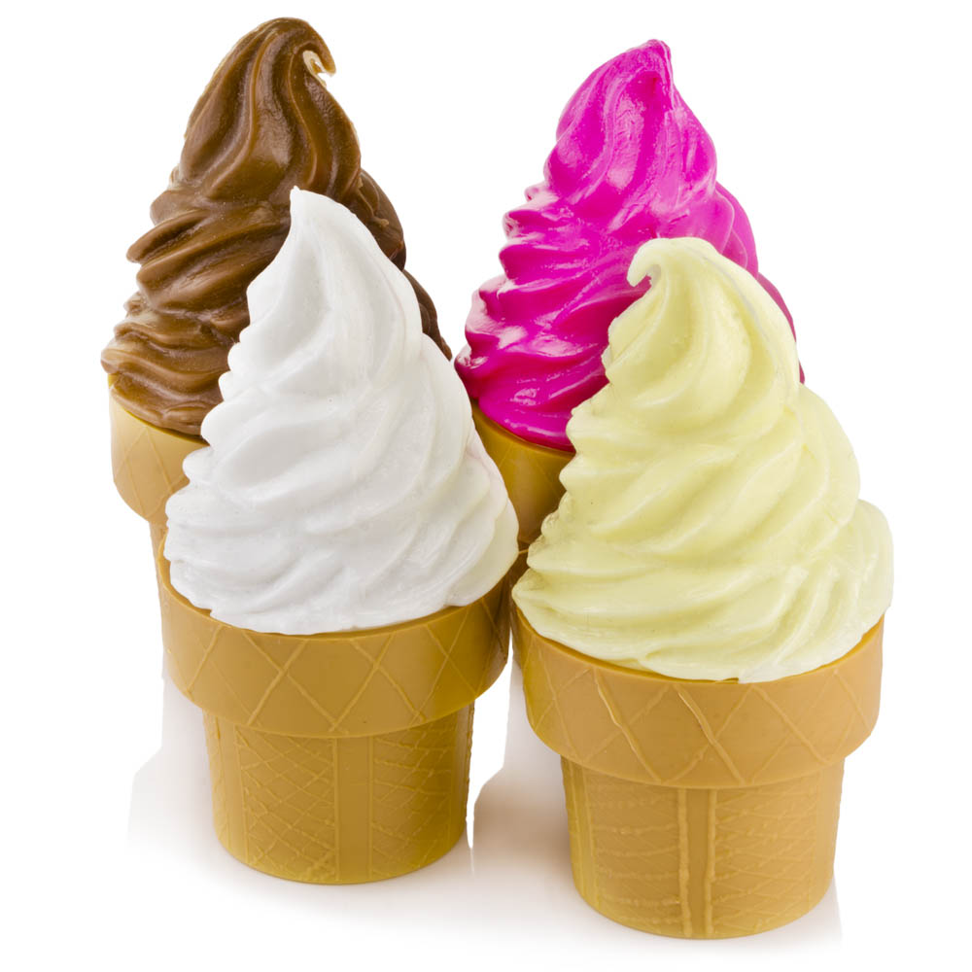
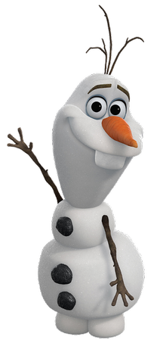

Qu 2

Anna has given Elsa a sequence of different numbers:

1, 2, 4, 8, 16, 32, .

What is the next number in the sequence?

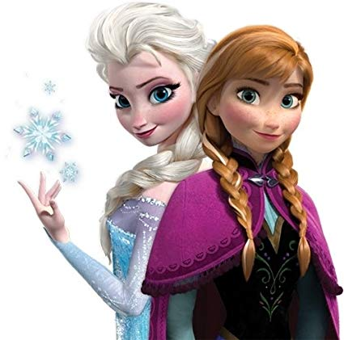

Qu 3

How many lines of symmetry are there on the snowflake below?

