Year 8

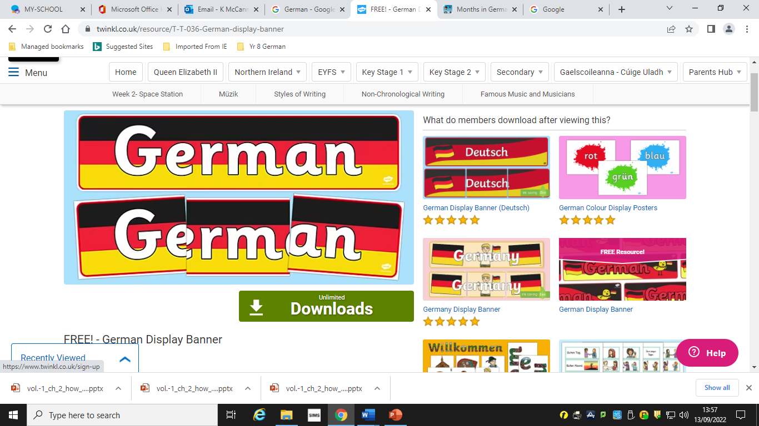

The Big Picture  
  
Wilkommen! Welcome!

In Year 8, you will have a fun introduction to German for part of the year. You will learn lots of useful words and phrases from a variety of topics. You will follow the escapades of a frog called Felix Frosch and a duck called Franzi Ente, who live in a special German letterbox.

**TOPICS:**

1. Hello! Greetings
2. How are you? Feelings
3. Pets
4. Colours and Countries
5. Fruit Salad: Expressing likes and dislikes
6. Clothes
7. Breakfast! Food & Drink
8. Body Parts
9. Numbers and Birthdays
10. Asking Questions

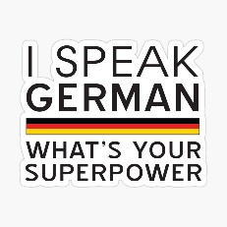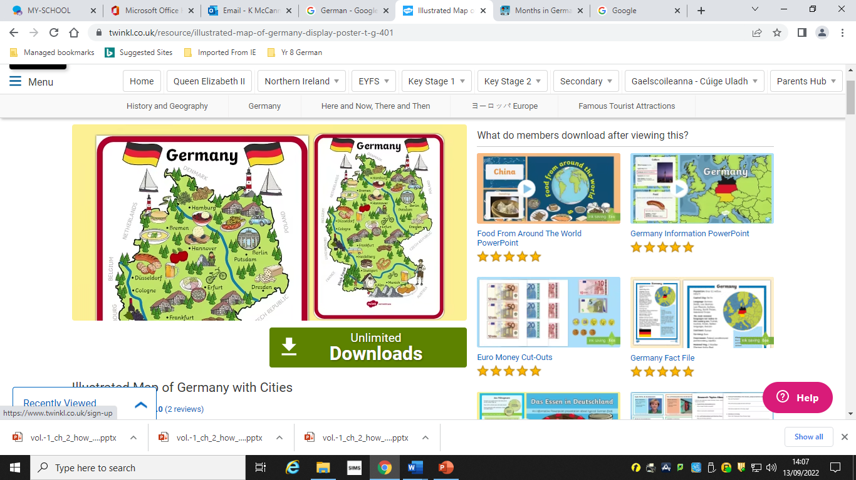

Homework

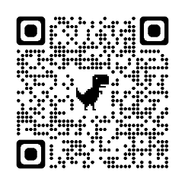  
Homework:  
You will have regular learning and written homework. It is very important that you learn new words thoroughly.  
Viel Spaß!