PRINCIPAL: S.W. BLACK, M.Sc.   | BALLYMENA ACADEMY,  GALGORM ROAD,  BALLYMENA,  CO. ANTRIM.  BT42 1AJ  TELEPHONE: 028 2565 2782/3  FAX: 028 2563 0855
5th November, 2021.

To: Parents of pupils in YEAR 11 (2021/2022)

Dear Parents,

While these are far from normal circumstances, your children have now embarked upon the course of study which will lead to their GCSEs in the summer of 2023. It is fair to say that what happens in the next two years will shape their educational futures and have, at the very least, a considerable impact on many other aspects of their lives.

At this time of year, we would normally be inviting you to a Year 11 Information Evening, however, given the ongoing restrictions around COVID-19, we have moved on-line in order to provide you with information, in an accessible way, to help you to support your child.

To that end, we would ask you to watch the video from myself and Mr. Moore (HOY – Year 11), which will give you insight into many aspects of the year ahead for your son/daughter. I have also attached the GCSE 2021/2023 booklet which gives a wide range of information pertaining to all aspects of GCSE studies at Ballymena Academy. This booklet outlines the assessment requirements for each subject, as they currently stand, though these may be subject to change in the event of school disruption due to COVID-19. We will provide you with updated information as and when necessary. You will also find attached a copy of the JCQ Guidelines for non-examination assessments.

You can access the Year 11 information video by clicking on the following link

https://youtu.be/kcmA2aJJihY

Our aim is to work with you to enable your children to enjoy their schooling, to gain maximum benefit from it and to secure excellent results. We want you to have confidence in this school’s ability to support your children and to help them to achieve the standards of which they are capable, in and out of the classroom.

In the last three years for example, 98% of Year 12 pupils achieved at least seven GCSE grades at A* - C, including English and Mathematics, with almost two-thirds of all grades being A* or A. Results of this kind represent an outstanding return for the young people in terms of the time and energy they invest in their studies and reflect very well on the quality of teaching provided. Our commitment to you and your child is to sustain a high quality education service and to seek to improve it where we can.

If you have any specific queries as the year progresses, please make contact with the school.

Yours sincerely,
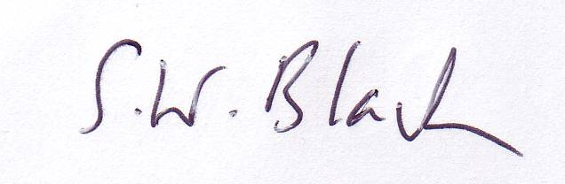

S.W. Black (Principal)

 |  | Bronze
E. Mail: info@balacademy.ballymena.ni.sch.uk www.ballymenaacademy.org.uk

