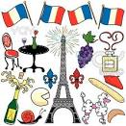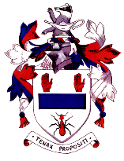
Year 10 French Big Picture

- Studio 2 Rouge Student books and workbook resources
- four language skills of speaking, listening, reading and writing
- skills practice in class with a range of activities and exercises linked to different topics

Term 1  Studio 2 Modules 1 and 3 | Term 2  Studio 2 Module 3 continued and module 4 | Term 3  Studio 2 module 4 continued and module 6
Module 1  Television  Cinema  Reading  Internet  Past tense – what you did yesterday evening  Module 3  Describing yourself in detail  Talking about relationships  Music  Style – clothes  Your interests | Module 3  Describing yourself in detail  Talking about relationships  Music  Style – clothes  Your interests  Module 4  Where you live  Describing your home  Meals – food and drink  Food shopping  Events - festivals | Module 4  Where you live  Describing your home  Meals – food and drink  Food shopping  Events – festivals  Module 6  World geography and French speaking countries  Science  History

What will I need?
- Studio 2 student book
- Studio 2 workbook photocopies
- 3 lined exercise books for Classwork, Vocabulary and Assessment
- A plastic folder to keep all your books in

Monitoring and evaluation
- Learning homework
- Written homework
- Core Assessment Tasks
- School exams

