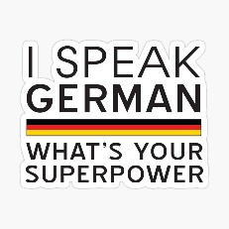
Year 10
The Big Picture
Wilkommen! Welcome!
TOPICS:
- Holidays
  - Comparing time frames
  - What you did on holiday
  - How you travelled
  - Weather
  - Problems
- Media
  - Cinema
  - TV
  - Reading
  - Screen time addiction
  - Opinions
  - Importance of Languages
- Healthy Living
  - Breakfast
  - German food
  - Recipes
  - Training
- School Trips
  - Rules
  - Daily Routine
  - Directions
  - Festivals
- Going out
  - Clothes
  - Plans to meet
  - Getting ready
  - How it went

In Year 10, you will build on your knowledge of German gained so far. You will learn lots of useful words and phrases from a variety of topics as covered in the Stimmt! 2 textbook. You will gain the language skills of Listening, Speaking, Reading and Writing.
Homework:
You will have regular learning and written homework. It is very important that you learn new words thoroughly.
Exams and Tests:
Before Christmas and in June you will have an exam which will test the skills of listening, speaking, reading and writing. You will also have regular vocabulary tests.
Some useful websites:
www.pearsonactivelearn.com
Viel Spaß!

