The Big Picture
Art and Design Year 10
‘DESIGN’
Term | Task | What I will be doing
Sept-Nov | Patterns and Design | -researching existing Patterns and William Morris  -creating own designs  -Repeating patterns and colour use  -Lino Printing technique
Nov-Dec | Linear Perspective | -Creating 3D through the use of line, 1 and 2point perspective, optical illusion  -using colour for Aerial Perspective  -drawing
 | Winter Art Exam
Jan-Feb | Amazing Spaces | -Architectural research and Gehry  -designing and 3D model constructions
March-April | Ceramics | -Researching existing ceramic vessels and artists  -building on spatial awareness, eye hand co-ordination, working in 3 D Coiling technique
April- May | Typography and Logos | -exploring typography and Logos, styles and function  -designing your own
May- June | ICT Design | Photoshop design task exploring imagery and typography
 | Summer Art Exam
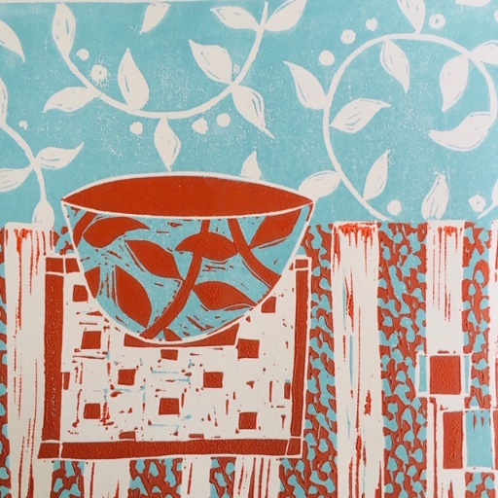
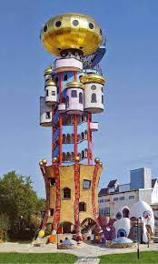
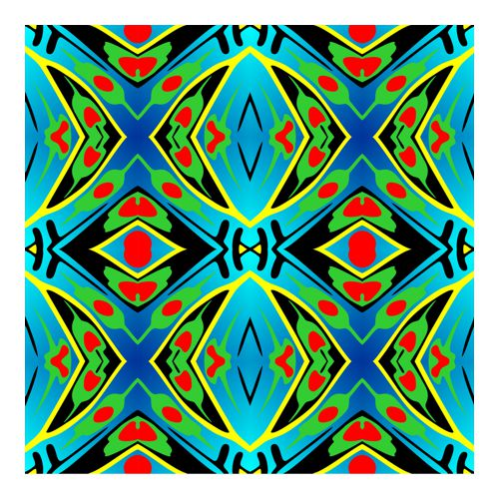
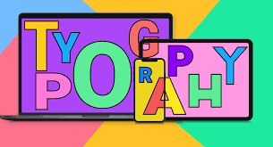
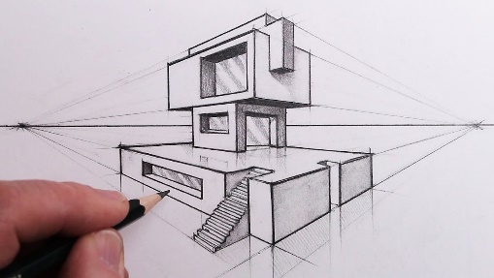
All projects over Year 10 will have a design element to the work, improving drawing and presentation skills, knowledge and understanding of ‘Form and Function’

