**Year 8 Science: “The Big Picture”**

Name: Class:

|  |
| --- |
| **Topics I will be studying** |
| Being a scientist  Topic test: Being a scientist |
| Exploring energy  Topic test: Exploring energy |
| Christmas Examination |
| Healthy body & mind  Topic test: Healthy body & mind |
| Solids, liquids & gases  Topic test: Solid, liquids & gases |
| Investigating Acids  Topic test: Investigating Acids |
| Summer Examination |
| Cells  Topic test: Cells |

j0187587

The workbooks for each topic include a checklist, which will give you more information about what you will be studying.



**Year 8 Self Assessment**

|  |  |  |  |  |
| --- | --- | --- | --- | --- |
|  | Assessed Homework | | Topic Test | |
| **Being a Scientist** | W5 Robert Bunsen /15 | | % | Average % |
|  | |  |  |
| Target: | | | | |
| **Exploring Energy** | Energy Changers /20 | | % | Average % |
|  | |  |  |
| Target: | | | | |
| **Christmas Exam** | % | Class Average  % | What I did well; | |
| Areas for improvement: | | | | |
| **Healthy body & Mind** | Experiment Write up /15 | | % | Average % |
|  | |  |  |
| Target: | | | | |
| **Solids, Liquids & Gases** | Density /25 | | % | Average % |
|  | |  |  |
| Target: | | | | |
| **Investigating Acids** | In the News Homework /20 | | % | Average % |
|  | |  |  |
| Target: | | | | |
| **Summer Exam** | % | Class Average  % | What I did well; | |
| Areas for improvement: | | | | |

**How to…**

Manage Information

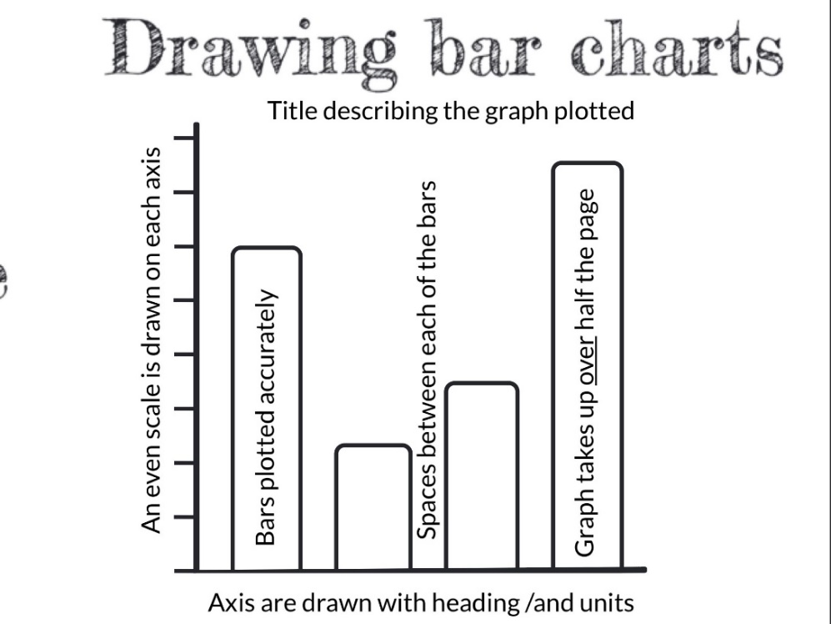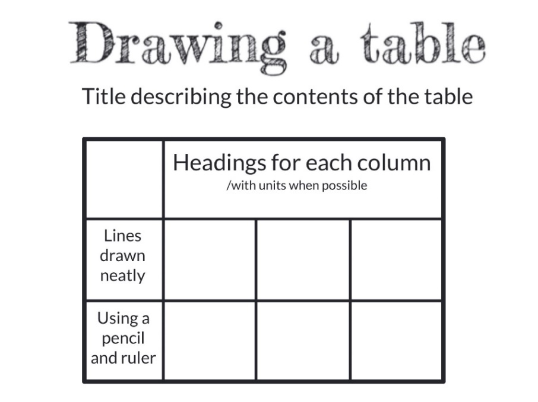

**How to…**

Revise for a test or examination

Use the three learning styles to help you study:

[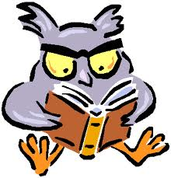](http://www.google.co.uk/imgres?q=auditory+learner&start=134&um=1&hl=en&safe=active&gl=uk&biw=1024&bih=472&tbm=isch&tbnid=KVD8bPNlCOYvvM:&imgrefurl=http://ascott-hs101experience.blogspot.com/p/study-skills.html&docid=EnaNPKy958LVNM&imgurl=http://3.bp.blogspot.com/_YPKGnZCTJB0/TPaRZs9vK8I/AAAAAAAAAD4/Ej5y3OVRRks/s1600/an00790_1.gif&w=345&h=360&ei=fT_rT-igG6rM0QWt_6nKBQ&zoom=1&iact=hc&vpx=485&vpy=115&dur=282&hovh=229&hovw=220&tx=90&ty=88&sig=106147458384159796993&page=10&tbnh=135&tbnw=129&ndsp=16&ved=1t:429,r:2,s:134,i:162) Visual

* Draw and label a diagram
* Make a mind map

Auditory

* Compose a rap or a song
* Record yourself reading information and play it back

Kinaesthetic

* Make a model
* Produce a card game

**How to…**

Write up an experiment you have done in science

Reports can be hand written or word processed using a plain font style.

**Title**

* An experiment to show/investigate…

[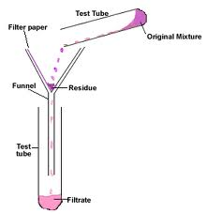](http://www.google.co.uk/imgres?q=chemistry+apparatus+section+filter+funnel&um=1&hl=en&safe=active&sa=X&gl=uk&biw=1024&bih=472&tbm=isch&tbnid=a205k1a1izSOfM:&imgrefurl=http://chemistryland.blogspot.com/&docid=7HBbuF0rLqjFSM&imgurl=http://4.bp.blogspot.com/-hQwR2VLFt-A/TX96nfLFcBI/AAAAAAAAAA8/0EfOnIjY6x0/s320/filtration.gif&w=288&h=296&ei=SD7rT4ynBqe_0QWlvczEBQ&zoom=1&iact=hc&vpx=90&vpy=2&dur=94&hovh=228&hovw=221&tx=100&ty=87&sig=106147458384159796993&page=1&tbnh=127&tbnw=124&start=0&ndsp=12&ved=1t:429,r:6,s:0,i:89)

**Diagram of equipment**

* Draw in pencil
* Use a ruler
* Label in pen
* Use at least ½ of the page
* List of equipment
* Note what you needed to do the experiment

**Method** (use numbered points)

* Explain how you did the experiment.
* Include what was changed and what was kept the same to make it a fair test.
* Explain what results were taken and how best to represent them (e.g. a table or graph).
* State any safety precautions taken.

**Table of results** (if required)

* Use a ruler and pencil to draw out the table.
* Include headings and units.

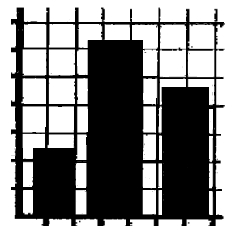**Graph** (if required)

* Write a title.
* Use at least 2/3 of the page.
* Rule axes with pencil
* Mark on the scales
* Label axes with headings and units
* Plot points
* Draw a best fit line or curve as required.

**Conclusion**

* Explain what you found out from your experiment.

**Experiment Checklist**

When you have finished your experiment write-up, use the list below to check you have completed all the parts.

1. Title
2. Diagram of Equipment
3. List of Equipment
4. Method
5. Table of Results
6. Graph
7. Conclusion