Ballymena Academy Science Department

Year 8 Science - Guidelines for Parents

General Advice

In class pupils should bring
- A ring binder (for worksheets, notes and tests)
- Pencil case with pen, pencil, rubber, ruler and highlighter. Colouring pencils are useful too.
- Learning Organiser

Homework
- Details written in Learning Organiser for the day it is due.
- Some teachers use a homework book, others use file paper.
- Use the Learning Organiser to help set out homework
- Write in blue or black ink; draw graphs and diagrams in pencil. (Use your Learning Organiser)
- You should sign your child’s written homework each night.

Organisation
- At the start of the year your child may need help getting organised. They will have science twice in the week. Do they have their books and materials ready for their class?
- Keep a copy of their timetable posted at home for easy reference.
- Be aware of the ‘Big Picture’ – an overview of the year’s work – your child will have a copy in their file; also can be found on school website.

Revision
- For topic tests and examinations (see ‘Big Picture’) your child should be an active learner – some ideas:
  - checking their work against learning outcomes for each topic
  - labelling blank diagrams,
  - reading and then listing the main points,
  - mapping out the main aspects of a topic
  - answering questions from text book
  - using a revision guide such as ‘KS3 Bitesize’ (book or website)
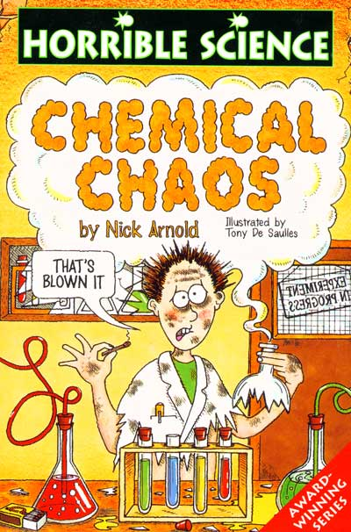
  - writing definitions, key facts or equations on post-it notes and sticking them round the room
  - getting a parent to ask them questions from their notes

- You might consider buying a science dictionary or titles to encourage reading like the ‘Horrible Science’ series.

Websites
(Adapted from ‘At home with Science’ www.planet-science.com)

The World Wide Web is a fantastic place for learning, but for every perfect page there are a hundred dodgy ones. If you don’t have Internet access at home, try the local library – many offer free access. Watch out for the temptation to just copy material from a website – make sure your child writes their homework in their own words.

www.planet-science.com
Contains excellent resources for both students and parents, including games and activities that won’t seem like school work (although full of curriculum links). There’s also a great section on science careers called Next Steps.

www.bbc.co.uk/schools/ks3bitesize/science/
For loads of easy-to-digest revision activities and tests for Key Stage 3.

http://www.bbc.co.uk/newsround/news
Science news from the BBC’s Newsround site

Activities you could try based on the Year 8 science topics (also see ‘The Big Picture’)

- Being a Scientist
  - Use a stop clock to time accurately; look at sporting records e.g. F1 racing
  - Visit the Armagh Planetarium (www.armaghplanet.com/) or
W5 (https://w5online.co.uk/)

- Exploring Energy
  - Visit a wind farm/windmill in Northern Ireland
  - Look at energy saving light bulbs; compare food labels when shopping

- Healthy body & mind
  - Ever thought of a family walk?
  - Have a look at the Eatwell Guide with your child https://www.food.gov.uk/northern-ireland/nutritionni/eatwell-guide

- Solids, liquids & gases
  - Look at the weather charts for Ballymena on the Internet (air pressure)
  - Try floating different vegetables & fruit in water or salt water

- Investigating acids
  - Have a look at some the food packets and jars in your home – how many food items contain acids?
  - Hydrochloric acid can react to give salt – for lots of information on common salt look at http://www.saltsense.co.uk/

- Cells
  - Find out about Robert Hooke in the library
  - Look at flowers under a magnifying glass

