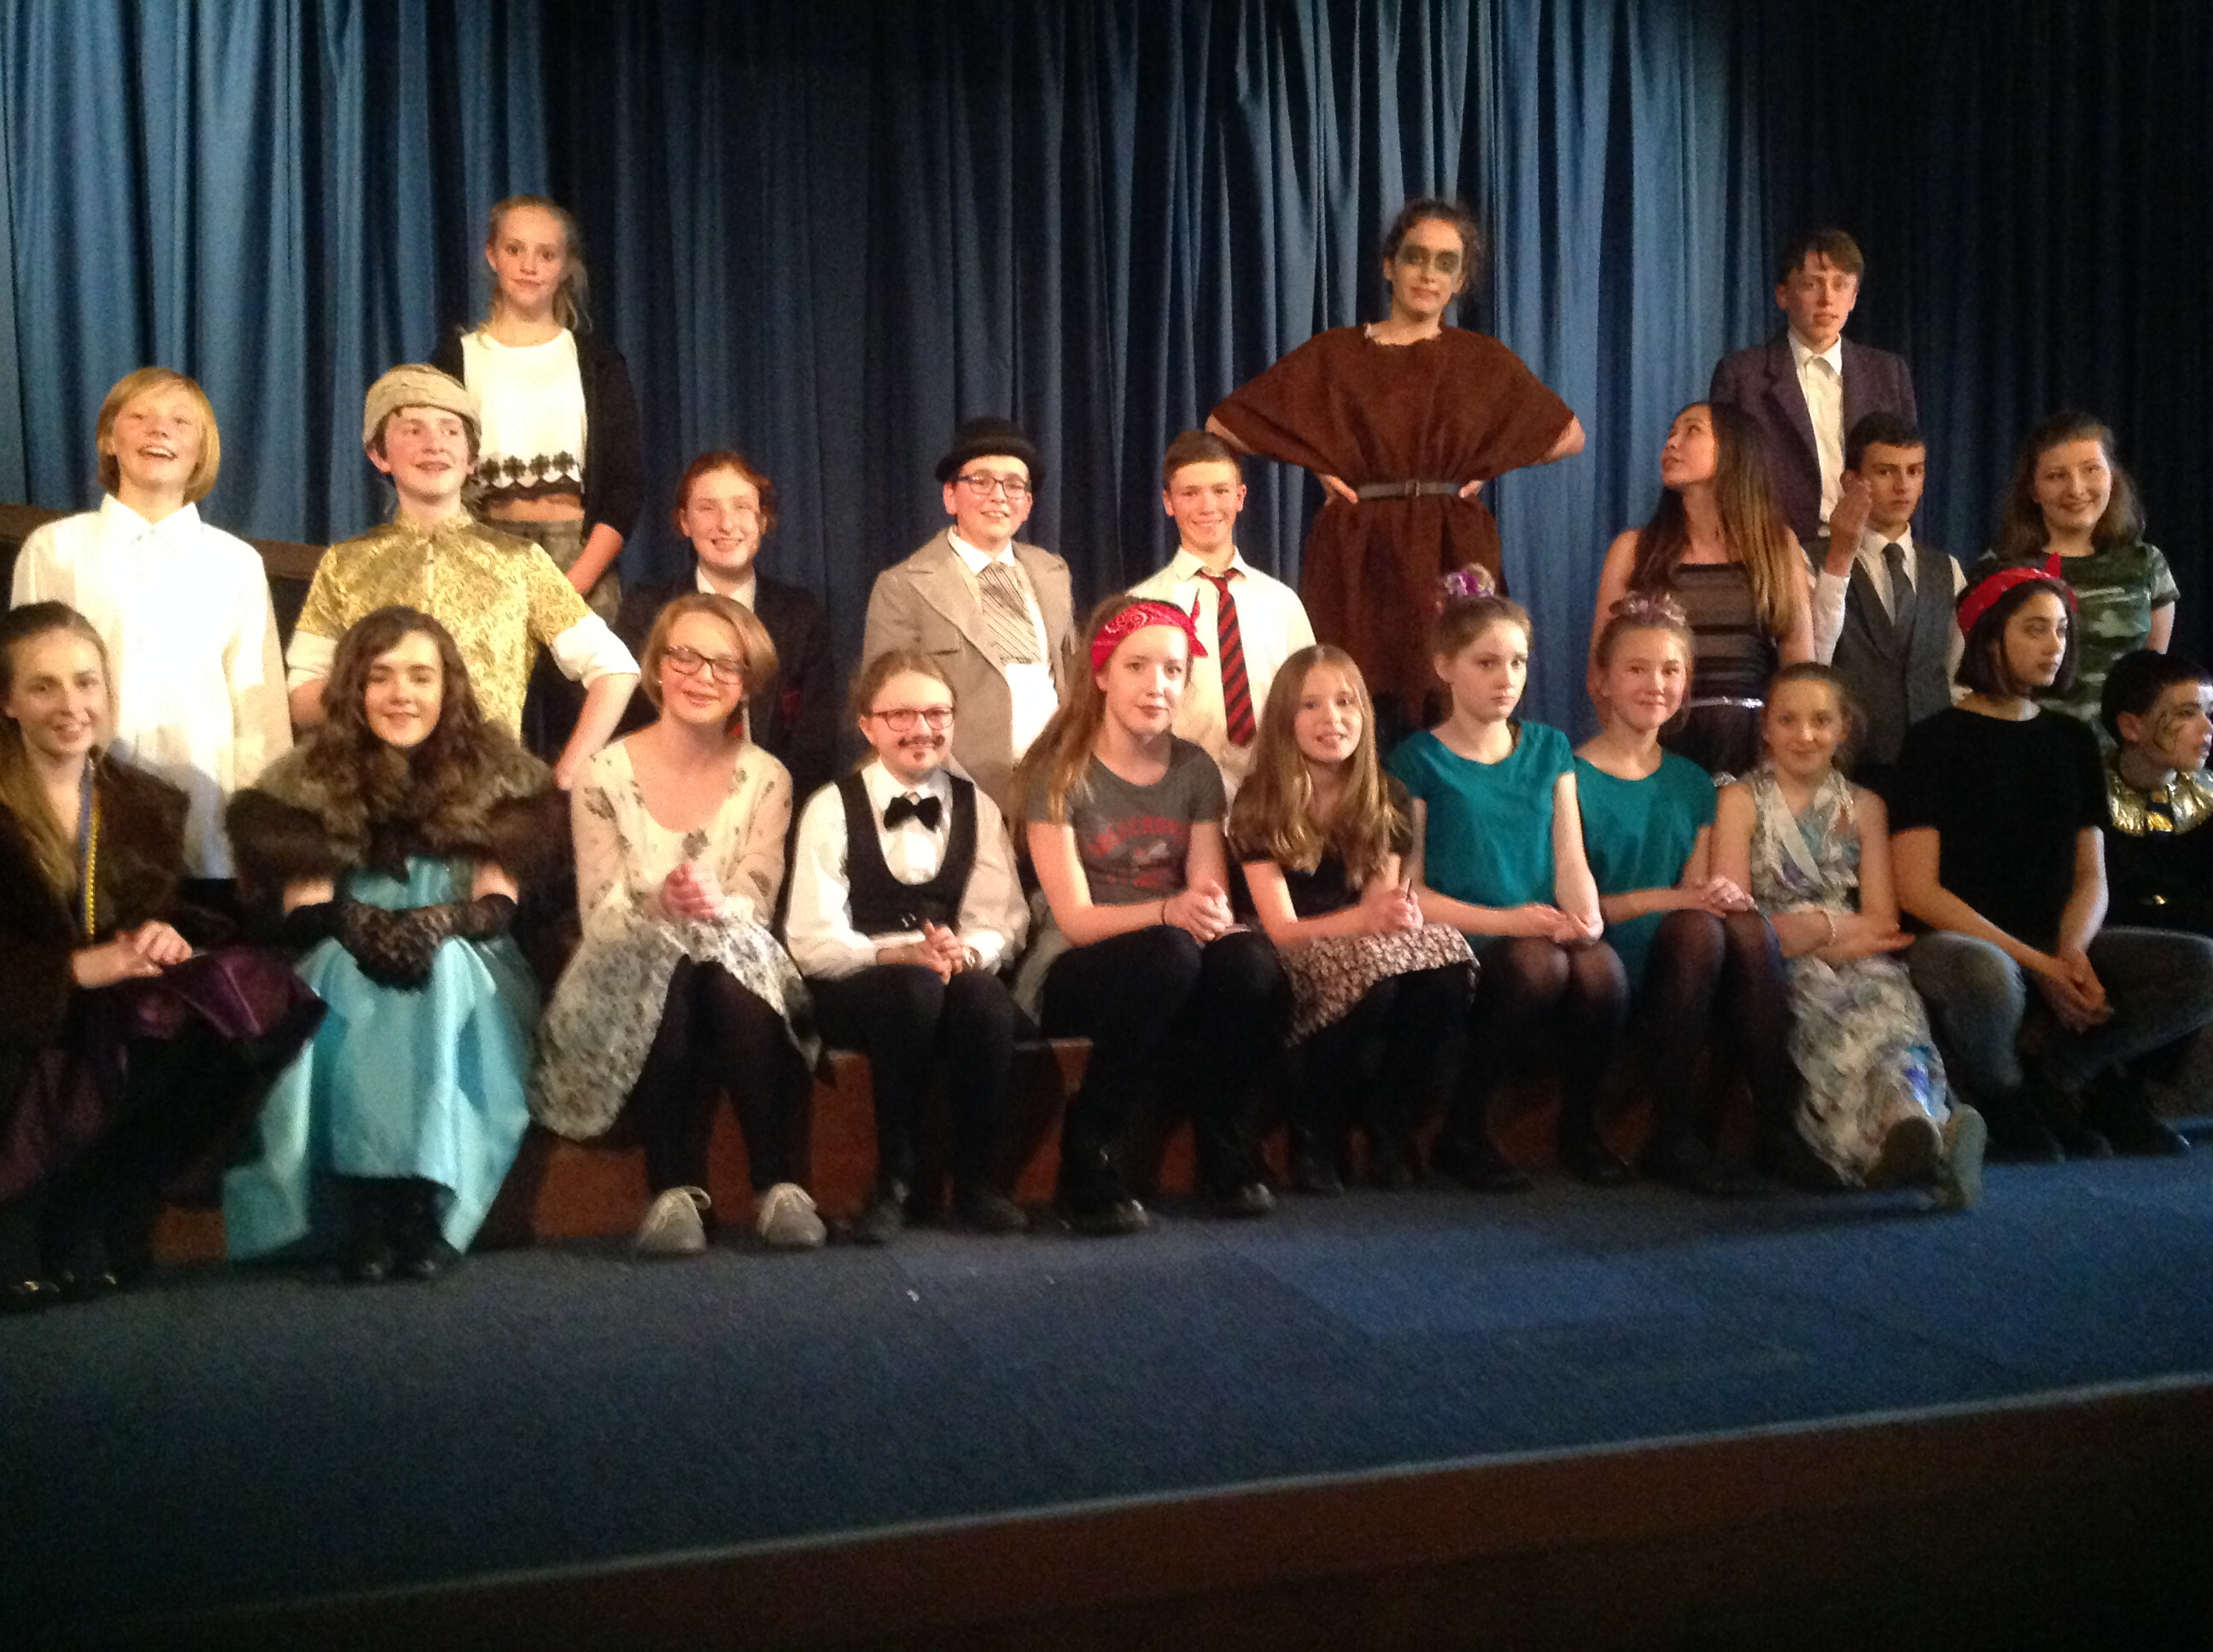
Parents' Guide to Key Stage 3 Drama

Drama at Key stage 3 is aimed at developing students' knowledge of drama as a concept rather than thinking "Eastenders" is all that acting is about. Drama is a vast array of different acting styles and ideas dating back over 2000 years and we look at many forms of theatre throughout history from Ancient Greece to Elizabethan Theatre from Naturalism to Pantomime and from stage fighting to physical theatre. Drama also seeks to encourage students to build on their Personal Learning and Thinking Skills. They will be exposed to group work in every lesson so will need to be team players. They will have to structure their rehearsal time and remain focussed in performance, working on concentration skills and time management. We also strive to improve confidence in public speaking and create a secure and happy environment for students to develop this confidence.

What skills does Drama enhance?

- Confidence
- Organising
- Meeting deadlines
- Working in a group
- Being sensitive to an issue
- Planning
- Appreciation/Evaluating
- Problem-solving
- Developing speaking and listening

You can support your child in developing her/his Drama skills by:

- Taking her/him on a trip to the theatre. Our local theatres do bring a good variety of quality performances and the Belfast theatres offer lots of opportunities to see major productions;
- Support her/him in researching topics or learning lines. You can do this by saying the other characters’ lines for her/him or encouraging her/him to record the lines on his/her phone;
- Ensure that your child is reflecting on what has been covered in class and is thinking about how to improve;
- Encourage her/him to develop an awareness of different styles of drama (not just soaps!).

