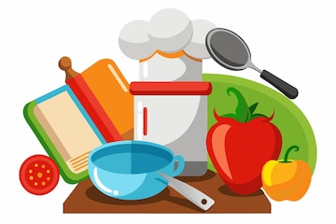
Year 8 Home Economics Revision Checklist

Christmas Examination
I Can:
Define food skills.
Identify equipment needed to weigh and measure.
Suggest 2 rules for measuring liquids in a measuring jug.
State the correct order for washing dishes.
Identify the 4 conditions bacteria need to grow.
Name 2 types of food poisoning bacteria.
List good personal hygiene practices
Identify rules to remember before preparing and cooking food.
Identify common types of accidents.
Identify pieces of kitchen equipment and state their use.
Describe a range of electrical appliances used in Home Economics.
Explain the 3 method of heat transfer.
Name the 3 main parts of the cooker and outline safety points for each part.
Home Economics Department
Ballymena Academy

