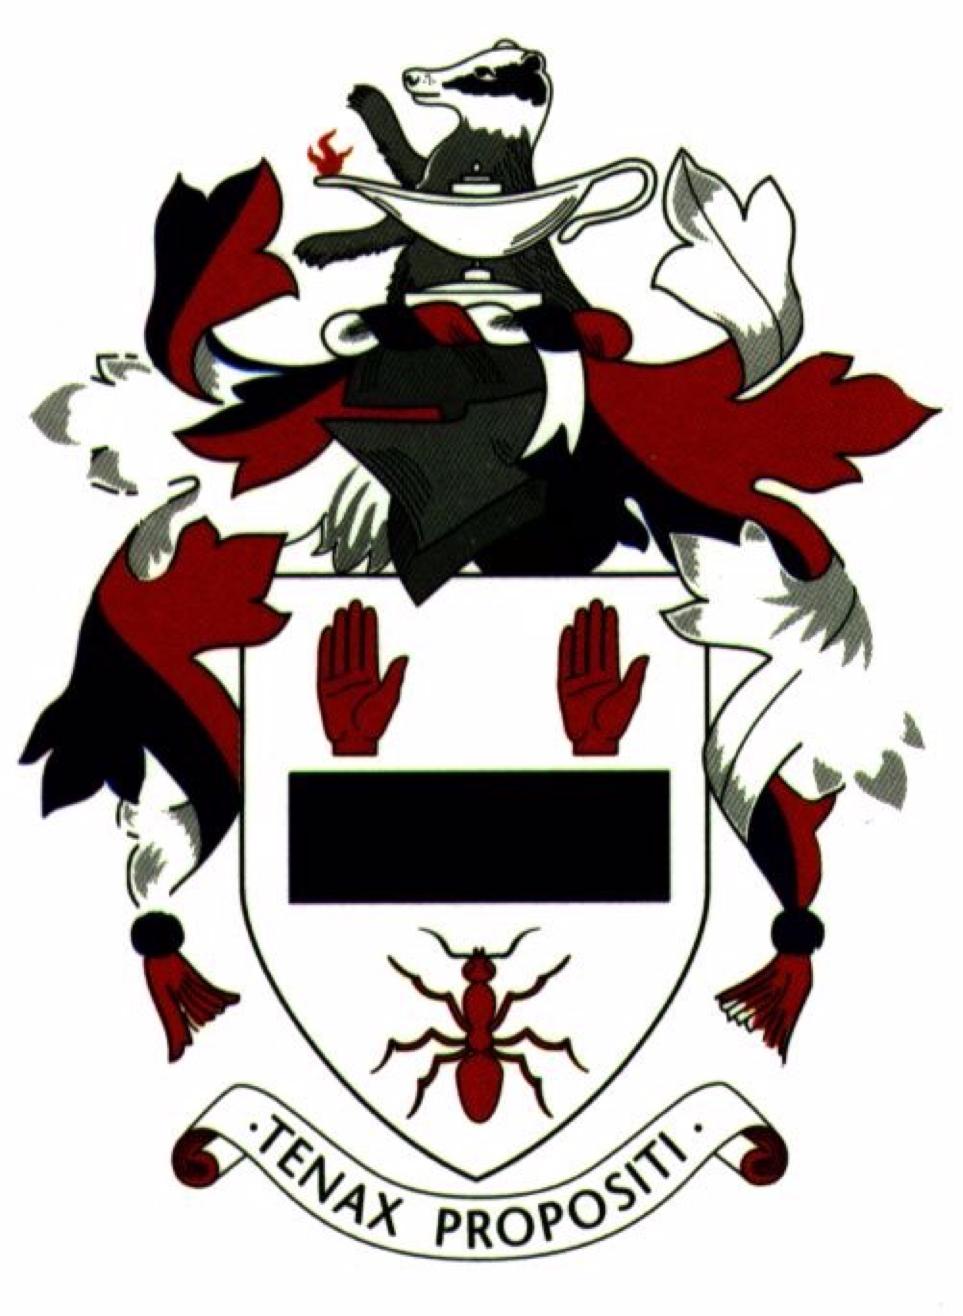

BALLYMENA ACADEMY

POLICY STATEMENT
IN RELATION TO
HEALTH AND SAFETY

[Approved at ……………
B of G meeting]

Ref. Health&SafetyPolicy (Reviewed MARCH 2022)

BALLYMENA ACADEMY

HEALTH AND SAFETY POLICY

This policy applies to all permanent and temporary accommodation on the site of Ballymena Academy and to all school users, including all visitors.

The policy applies to all users of the school site who are attending organised activities or making legitimate use of school facilities.

The policy is to be observed by all school teaching and support staff. The school has a number of documents describing current procedures, particularly those relating to emergency evacuation and to particular departments’ working practices. The latest versions or references to them are included in the school’s Health and Safety Policy folder, copies of which may be obtained from the Principal’s Secretary or from the Staffroom, the Health and Safety Officer or the Maintenance Officer.

1. | The Governors of Ballymena Academy understand and accept the obligation, under the Health and Safety at Work Act 1974 and associated legislation, to provide a safe and healthy environment for all users of the premises. The Governors have a statutory duty to provide a safe and healthy place of work for all employees. In certain circumstances this duty extends to those persons engaged to provide services for the school.
2. | As far as is reasonably practicable, governors expect to provide
a) | safe systems of work and healthy working conditions and associated guidance and training;
b) | first aid facilities and trained first aid personnel;
c) | safe premises, plant and equipment;
d) | arrangements for the safe use, handling, storage and transport of articles and substances;
e) | safe means of access and egress;  (See Appendix 1 - Policy for Vehicular and Pedestrian Access)
f) | appropriate security arrangements;
g) | welfare procedures
h) | opportunities for the participation of safety representatives, of each employee grouping, in promoting health and safety at work;
i) | Promotion of health and safety training to ensure competence and awareness.
3. | Governors expect the school’s employees to
a) | support and implement this policy, including procedures listed in Appendix 2, “Designated Responsibilities and Procedures”;
b) | set a personal example through safe behaviour, and comply with appropriate safety warnings;
c) | make use of the protective equipment available; ensure that pupils make use of protective equipment; accept that the safety equipment, protective clothing and procedures provided must be employed as appropriate to the hazard and in the manner prescribed;
d) | familiarise themselves with procedures for emergency evacuation;
e) | only use equipment or machinery which they are competent to use or have been trained to use;
f) | satisfy themselves when using plant, machinery, tools or equipment that such are not defective and that such are suitable for the task; where there is doubt refer equipment to an appropriate supervisory officer; when required, undertake the testing of equipment provided, in accordance with published requirements; and ensure that it has current valid test certificates where appropriate;
g) | ensure that any equipment to be purchased, hired or installed by the school is suitable for its intended use and location and complies with the appropriate safety regulations. Full operating and maintenance instructions, written in English, must be provided and made available for use;
h) | report to the designated person if inadequacies are detected in any safety procedures;
i) | be conscious of the health, safety and welfare of themselves, their colleagues, persons in their care and members of the public, and do nothing by act or omission which will adversely affect themselves or those others;
j) | report all incidents, notifiable diseases, dangerous occurrences and potentially hazardous incidents in accordance with prescribed procedures;
k) | teach safety as an integral part of courses, both by formal teaching, where appropriate, and by example, ensuring that no school user sees or is allowed to do anything which does not correspond to the best industrial or teaching practice;
l) | prohibit any pupil who refuses to adopt safe working procedures from taking part in the lesson, and refer the pupil so that appropriate disciplinary action can be taken;
m) | inform contractors and other workers not employed by Ballymena Academy of appropriate health and safety regulations and of appropriate points from this health and safety policy;  Please note: All employees should be aware that failure to discharge the obligations placed on them by this policy and its appendices, or by any relevant statutory provision, may make them liable to prosecution by the Health and Safety Executive, or to disciplinary action under the school’s disciplinary rules.
APPENDIX 1
POLICY ON VEHICULAR AND PEDESTRIAN ACCESS

This policy is intended to form an Appendix to the Health and Safety Policy for Ballymena Academy.

Aims of the Policy

The Board of Governors of Ballymena Academy will encourage and promote, for all school users

i) | the safe access and passage of traffic to, from and within the school site and
ii) | the safe parking of vehicles, including bicycles and motorbikes , within the school site.  Achievement of the Aims  The Board of Governors will
i) | monitor the arrangements for vehicular access to, from and within the school site and make changes when considered necessary to improve safety
ii) | monitor the parking facilities within the school site and make any changes necessary to improve safety
iii) | identify and promote those areas where parking is permitted
iv) | establish and promote the method of vehicular access to, from and within the school site
v) | monitor the parking and access situation on the public highway fronting the school site and make recommendations to the D.O.E. as considered necessary and appropriate to improve safety.  The Board of Governors will inform all school users whenever possible and practical of
i) | those areas where parking is permitted
ii) | the access arrangements to, from and within the school site.
The Board of Governors, although seeking to ensure the security of vehicles, does not accept responsibility for theft of, or damage to, vehicles present on the school site.

During frosty weather conditions, although ground staff do their utmost to salt the driveways, it is not possible to ensure that every area be treated within the time available on a given morning. In such conditions all users are cautioned to exercise great care.
APPENDIX 2
DESIGNATED RESPONSIBILITIES AND PROCEDURES

1. | The Board of Governors  The Board of Governors is responsible for:-  - formulating, ratifying, implementing, monitoring and reviewing the school Health and Safety Policy;  - the site and premises being maintained in a safe condition and that appropriate fencing is allocated to this area;  - prioritising action on health and safety matters where resources are required from the school budget;  - regularly reviewing health and safety arrangements (minimum annually) and implementing new arrangements where necessary;  - promoting high standards and developing a positive culture of health and safety within school;  - ensuring that employees have necessary competence to conduct their duties in relation to health and safety matters;  - risk assessments are completed and recorded of all the school’s work activities (including those off-site) which could constitute a significant risk to the health and safety of employees and others;  - the policy and other health and safety documentation is drawn to the attention of all employees.
2. | The Principal  Responsibility for the implementation of the Health and Safety policy and procedures within the school lies with the Principal. In the Principal’s absence, the Deputy or the Vice-Principal (Corporate Services) will assume this responsibility.
3. | The Senior Leadership Team  The Vice-Principal (Corporate Services) has delegated responsibility for organising the arrangements for health and safety in school and for liaising with the Health and Safety Officer.  The Senior Leadership Team expects to
a) | ensure that the School is so organised that there is no unacceptable risk to members of staff, pupils, or other users of property;
b) | ensure that all staff are properly briefed and trained in their duties and responsibilities as part of the general programme of staff development;
c) | set a personal example and encourage a safe attitude towards work amongst all employees;
d) | ensure that there are safe systems of work and that members of staff and pupils use protective equipment provided, observe the standards laid down by law and co-operate with agreed safety measures;
e) | co-operate with the safety representatives;
f) | nominate a member of staff to act as Safety Officer, working closely in conjunction with the Principal.
4. | The Health and Safety Officer  The responsibilities of the Health and Safety Officer include
a) | monitoring and implementing the general safety programme;
b) | carrying out a regular programme of safety inspections;
c) | maintaining health and safety documentation and associated records to ensure they remain up-to-date with current legislation and good practice;
d) | ensuring that correct accident reporting procedures are followed to ensure appropriate accidents, incidents and other issues are investigated;
e) | analysing incident reports;
f) | establishing and monitoring first aid procedures;
g) | establishing and monitoring emergency fire procedures;
h) | establishing and monitoring emergency evacuation procedures;
i) | establishing protective clothing and equipment needs and establishing monitoring procedures for their use;
j) | assessing hazards and associated risks;
k) | attending appropriate health and safety training courses to enable them to discharge his duties effectively;
l) | promoting health and safety matters throughout the school and assisting the Principal in the implementation of the Health and Safety policy and procedures;
m) | conducting routine health and safety inspections and implementing a method of internal audit;
n) | implementing procedures for authorising school visits;
o) | providing health and safety induction training for new employees and other members of staff as and when required;
p) | ensuring that statutory inspections are completed and records kept;
q) | ensuring that emergency drills and procedures are carried out regularly and monitored for effectiveness;
r) | monitoring contractors on site and conducting formal documented induction;
s) | chairing meetings of the school’s Health and Safety Committee;
t) | hold relevant information on health and safety which will include Health and Safety Executive (HSE) guidance notes, codes of practice and copies of this policy and its appendices.  Please note: In practice, some of these responsibilities are delegated to or shared with the Maintenance Officer or other ancillary staff (Lab. Technicians etc.)
5. | Health and Safety Representatives  At least one safety representative of each employee grouping attends meetings of the school Health and Safety Committee in order to
a) | assist communication between members, the Health and Safety Committee and the Health and Safety Officer;
b) | assist in dealing with problems involving health and safety in accordance with agreed school procedures;
c) | carry out regular inspections of the workplace with the Health and Safety Officer.
6. | The School Health and Safety Committee  It is intended that most health and safety matters should be dealt with promptly within each department. Only in exceptional circumstances will it be necessary to refer matters to the Health and Safety Committee. The committee meets at least twice per year to formulate safety rules and consider hazards and safety problems throughout the school. Minutes are circulated to committee members and copies are available in the Staff Room. Further copies are passed to the Senior Leadership Team (SLT) and to the Board of Governors.  The functions of the Health and Safety Committee are
a) | to evaluate the statistics associated with school incidents and notifiable diseases;
b) | to examine safety audit reports;
c) | to consider reports which safety representatives have submitted;
d) | to consider reports and factual information provided by inspectors for the enforcing authority appointed under the Health and Safety at Work Act;
e) | to assist in the development of school safety rules and safe systems;
f) | to monitor the effectiveness of the safety content of staff training;
g) | to monitor the adequacy of health and safety communication and publicity in the school;
h) | to provide a link with the appropriate inspectorates of the enforcing authority;
i) | to make recommendations to the Board of Governors.
7. | Education and Training  The SLT determines the education and training needs of staff in consultation with the Health and Safety Officer, and ensures that training in safety and related topics is kept under constant review.
The Health and Safety Officer is responsible for drawing to the attention of all employees the following health and safety matters as part of their induction training:-

- Health and Safety Policy;
- Local Asbestos Register and disturbance procedure, as appropriate;
- Risk assessments;
- Fire and other emergency arrangements;
- Accident and reporting arrangements;
- First Aid (administration of medicines arrangements);

- Safe use of work equipment;
- Good housekeeping, waste disposal and electrical arrangements;
- Hazard reporting and maintenance procedures;
- Special hazards and responsibilities associated with their work activity;
- Special needs of pupils relating to Health and Safety.

8. | Protective Clothing and Equipment  The School Health and Safety Officer and Maintenance Officer determine the type and quantity of protective clothing or equipment necessary for the protection of staff, pupils and visitors, and the circumstances in which clothing or equipment are used if not already directed by statutory regulations. In general, staff issued with protective clothing wear that protective clothing during work hours. Sufficient protective equipment is available for use by staff and pupils. In areas where the wearing of protective equipment is a statutory requirement, members of the public visiting the area are expected to wear the equipment available.
9. | Fire and Emergency  The School Health and Safety Officer ensures that a Fire Action notice giving detailed instructions of the action to be taken in the event of fire or other emergency, the points of assembly and the exit points, is displayed in every classroom, work room and office. Two practice fire drills are carried out annually.  The Health and Safety Officer ensures that fire alarms and fire fighting equipment are regularly tested and inspected to meet legal requirements.  All staff must familiarise themselves with, and must ensure that they fully understand, the instructions of the emergency evacuation procedure. Staff must ensure that escape routes are not obstructed and that whenever the building is occupied the emergency exits are free to open and that smoke-stop doors are not wedged in the open or shut position.
10. | Incidents and Injuries  Incidents and injuries to any person on the school premises must be reported  - verbally, or in writing, to the Principal immediately after the incident;  - on the appropriate report forms (available in the Staffroom) to the Health and Safety Officer within 24 hours.  [The Health and Safety Officer should be supplied with two additional photocopies - one for the Head of Year and the other for the Insurance Company.]  Where accidents are found to be caused by faulty plant, equipment, premises or unsafe systems of work, action must be taken to remove or isolate the hazard and warn people until necessary modifications or repairs can be made.  Record books kept in workshops and laboratories should be completed.  A supply of “Dangerous Occurrence” forms is also kept in the Staffroom.
11. | First Aid and Administration of Medicines  First Aid administration procedure of medicines is dealt with by the School Nurse and/or a qualified team of First Aiders - see also Policy on Pupil Medical Conditions – (administration of medicines).
12. | Dealing with Hazards or Potential Risks  If a problem or hazard occurs, or appears likely to occur, it should be drawn to the attention of the appropriate Head of Department. If the problem or hazard puts people at immediate risk, the member of staff must warn people in the vicinity; make appropriate arrangements; and take such steps as are reasonably possible (without putting people at risk) to reduce or, if possible, eliminate the risk.  On identifying a hazard or potential risk, the following agreed procedure is to be followed:-
a) | member of staff or Health and Safety Representative assesses the situation;
b) | the matter is reported to the appropriate member of Staff;
c) | if the matter cannot be resolved, the Safety Representative reports the matter to the Health and Safety Officer (using a “Dangerous Occurrence” form);
d) | if the matter cannot be resolved by the Health and Safety Officer, the matter should be referred to the Principal;
e) | serious or repeated difficulties are to be reported to the Health and Safety Committee.
13. | Procedures governing Out of Classroom Educational activities for pupils.  Appropriate policy detailed on Staff Information Area on Google Drive  .
14. | Control of Substances Hazardous to Health (C.O.S.H.H. Regulations 2002)  A detailed list of all substances which are hazardous to health is kept to comply with the regulations, and risk assessment is regularly updated for every department.
15. | Refer to the Staff Information Area on Google Drive, for details of other matters including briefing of new staff and pupils, inspection of fume cupboards, one-way traffic flow, speed limit, cycling proficiency scheme.
16. | Asbestos  The Maintenance Officer has overall responsibility for:-  - managing asbestos;  - ensuring that the asbestos management plan is implemented and maintained.  The Asbestos Register is kept by the Maintenance Officer.
17. | Legionella  The Maintenance Officer has overall responsibility for:-  - managing Legionella;  - maintaining a legionella risk assessment;  - ensuring that remedial actions from the risk assessment are followed through;  - the water temperatures and other maintenance tasks associated with the water system are taken monthly;  - the inspection of little used outlets is carried out weekly, including school closure periods.  The Logbook is kept by the Maintenance Officer.
18. | Maintenance Work Equipment  The Maintenance Officer is responsible for selection, inspection, maintenance, training, services, safe use and risk assessment.
19. | Vehicles  The Corporate Services Manager is responsible for:-  - arranging insurance and maintenance of vehicles; authorising the use of the school minibus; ensuring risk assessments are completed, drivers have appropriate driving qualifications and insurance;  - maintaining a list of authorised drivers for the school minibus;  - employees should not use their private vehicle for official business unless they have gained authorisation and provide appropriate insurance and a vehicle that is road worthy and fitted with suitable seat belts for each passenger.
20. | Personal Protective Equipment (P.P.E.)  Suitable PPE will be provided, where identified as necessary in a risk assessment. All employees are responsible for informing their line manager as soon as they become aware of a need to require or replace PPE.
21. | Use of Premises Outside School Hours  The Vice-Principal (Corporate Services) is responsible for co-ordinating the use/letting of premises outside school hours (see Use of Premises Policy).
22. | ICT Equipment  The ICT Technician is responsible for inspection, maintenance, safe use and risk assessment. The ICT Co-ordinator is responsible for selection and training.
23. | Equipment provided for Pupils with Special Educational Needs  SEN Co-ordinator/Teaching Assistants are responsible for ensuring that SEN equipment is kept in good working order and serviced appropriately.
24. | Lifts  The Maintenance Officer is responsible for ensuring that lifts receive a thorough examination and service every six months.
25. | Caretaking and Cleaning Equipment  The Maintenance Officer is responsible for selection, inspection, maintenance, training, safe use and risk assessment.
26. | Physical Education Equipment  Head of Physical Education is responsible for the selection, inspection, maintenance, training, supervision on safe use and risk assessment.
27. | Stage Lighting Equipment  The Maintenance Officer is responsible for selection, inspection, maintenance, training, supervision, safe use and risk assessment.
28. | Mobile Staging and Seating  The Maintenance Officer is responsible for selection, inspection, maintenance, training, supervision, safe use and risk assessment.
29. | Housekeeping and Waste  All members of staff are responsible for arranging to clean up spillages which occur whilst they are in charge of the area concerned. Other spillages, leaks or wet floors should be reported to the cleaning staff.  All staff are responsible for ensuring good housekeeping of their own work area, e.g. classrooms, offices, workshops and storage areas etc.  When waste needs to be disposed of it should be reported to the Maintenance Officer.
30. | Catering  The School Meals Supervisor is responsible for the preparation of food, the nutritional standard of meals, the maintenance of safety and hygiene standards in kitchen/catering areas and producing suitable training for staff.
31. | Electrical Equipment  All portable electrical equipment is tested (Portable Appliance Testing – PAT) every year.  A copy of the inventory of the electrical equipment tested, including results, should be held by the Health and Safety Officer.  All defective equipment must be taken out of use immediately and reported to the School Maintenance Officer.  Privately owned appliances must typically not be used on the school premises, unless their use has been approved and/or they have been tested under the PAT test.
32. | Repairs and Maintenance  All damage and defects in the premises must be reported to the Maintenance Officer who will keep a record of such and the action taken.
33. | Visitors  All visitors must report to Reception where a signing-in system is in operation. Visitors should wear a School Visitors’ badge when on the premises.  Contractors working on the school premises would be made aware of the health and safety arrangements applicable to them by the Maintenance Officer.
34. | Contractors  Contractors should notify the Maintenance Officer of any hazards arising from their activities, which may affect the occupants of the school. The Maintenance Officer will be responsible for monitoring the work of contractors to ensure the safety of pupils, staff and visitors. In the interests of safety, major works should take place out of school hours during school holidays.
35. | Department Safety Policies  All departments have lodged specific statements of policy with the Health and Safety Officer and these are available for inspection by all employees. Employees will be furnished with copies of their departmental statement.
36. | Health and Safety information is available from the Health and Safety Officer.

