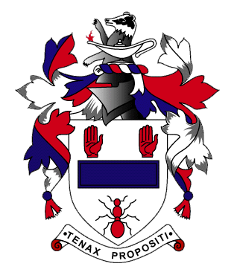
Ballymena Academy
HOCKEY COACH (1st XI and 2nd XI)
JOB DESCRIPTION
Ballymena Academy
The School
Ballymena Academy is a co-educational, non-denominational Voluntary Grammar School founded in 1828. Current enrolment is 1200 pupils ranging from age 11 – 18 years. The School employs approximately 130 staff, 80 teaching staff and 50 non-teaching staff, with current Principal, Mr. S.W. Black.
The School is situated on a magnificent 88 acre site which includes two synthetic hockey pitches amongst extensive sports facilities.
Hockey Coach (1st XI and 2nd XI) - Job Description
The Hockey Coach is appointed by the Board of Governors and his/her responsibilities are laid down by the Board. The Hockey Coach will be responsible to the School Principal and Teacher i/c Hockey.
Salary will be negotiable and dependent on the candidate’s knowledge and experience. The normal hours of duty are from 3.30 p.m. to 5.00 p.m. - Monday and Thursday, 2.00 p.m. to 3.30 p.m. - Wednesday and 9.00 a.m. – 12.00 noon - Saturday. However, the employee will be required to work such further hours as are necessary to discharge the duties attached to the position efficiently and conscientiously. The duties of the post will also require further attendance at certain evenings during the school year, at weekends and for emergencies.
Responsibilities
- To produce and implement a well-structured and progressive coaching programme to meet the squad and individual needs of Ballymena Academy Hockey Club 1st XI and 2nd XI.
- To abide by the values and Code of Conduct of the School.
- Coach the squad during match day fixtures.
- Oversee selection for all 1st XI and 2nd XI matches, in line with the Club Selection Policy.
- To work in a collaborative manner with other senior coaches and, in particular, with the Teacher i/c Hockey.
- Support the integration of our junior players into the senior training/playing environment and development of all players.
- To plan individual training sessions for 1st XI and 2nd XI.
- To have responsibility for video analysis of 1st XI and 2nd XI fixtures.
- To co-ordinate pre-season training and training/matches over holiday periods, as agreed with the Teacher i/c Hockey.
- To deliver CPD sessions for other coaches.
- To liaise with the Strength and Conditioning coach and Teacher i/c Hockey to provide an appropriate Strength and Conditioning programme for senior hockey players.
- To collaborate with the Teacher i/c Hockey to devise a development plan for Ballymena Academy hockey and to undertake an annual review of the plan.

