PRINCIPAL: S.W. BLACK, M.Sc.   | BALLYMENA ACADEMY,  GALGORM ROAD,  BALLYMENA,  CO. ANTRIM.  BT42 1AJ  TELEPHONE: 028 2565 2782/3  FAX: 028 2563 0855
September, 2019.

To: Parents of pupils travelling off-site.

Dear Parents,

With reference to pupils returning to school after trips off-site, including sporting fixtures, our practice has been to allow pupils to get off the bus at various points before reaching school – the final destination of the journey. We believe this is sensible practice and means that parents are not called upon for any unnecessary extra ‘taxi’ duties. However, we must have parental permission to allow any pupil to get off a bus before it reaches school.

With this in mind I would ask you to complete the form below and return it to the School Office or your child’s P.E. teacher. (Your child should bring the form to the teacher.) A Card will then be issued to all those for whom parental permission has been received. Teachers have been instructed that in the absence of this Card they should not allow pupils to get off the bus, other than at school.

I am sure you will appreciate that this measure is in everyone’s best interests. Please note that in signing the form below you:-
(a) Give permission for your child to get off the bus at a point other than the school.
(b) Indicate the point(s) at which you allow your child to get off.
(c) Accept that the school and its staff do not have any responsibility for your child’s safety or welfare once she or he has got off the bus.
(d) Allow your child to get off at the specified point(s) until you provide the school with written notice of withdrawal of this permission.

If a child forgets their card, permission may also be sought via a phone call from the parent. The responsibility is with the child to ensure the person giving consent is actually a parent/guardian. Parents may write a signed letter of consent for a one-off drop off. Any parent wishing to take their own child home from a venue must inform the supervising member of staff directly. Parents may, on occasion, offer to take other pupils home. This will only be permitted if either written or verbal (via a phone call) consent has been given by the other pupil’s parents and is presented to the supervising member of staff. If there is no parental consent, either in written or verbal form, pupils must travel to and from the venue on the transport provided by the school.

Parents/Guardians of pupils who decline to use the school transport provided accept responsibility for making their own transport arrangements. Organising staff must be informed in advance and provided with evidence of parental permission, if a pupil wishes to make their own transport arrangements. N.B. For Senior Games (Wednesday p.m.) and for regular scheduled sporting practices off-site, a separate procedure applies. The appropriate form, to be signed by Parent/Guardian, should be obtained from and returned to the P.E. Department.

Yours sincerely,
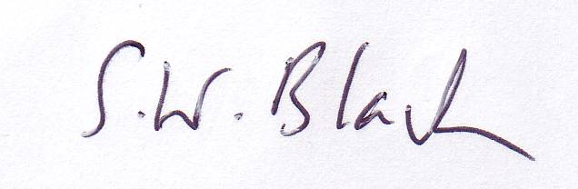

S.W. Black (Principal)

……………………..cut…………………………….along……………………………….here………………………………………

BALLYMENA ACADEMY

PARENTAL PERMISSION TO
GET OFF BUS BEFORE REACHING SCHOOL

Pupil Name: Reg. Group:

I have read the Principal’s letter in relation to this matter and I permit my child to get off school transport at the following point(s) until further notice.

I recognise that once my child gets off the bus the school and its staff are no longer responsible for her or his safety. I also acknowledge that this permission is on-going and I will provide written notice of withdrawal, as appropriate.

Signed: Parent / Guardian Date:

